Homework Assignment Week 6
Objective:
- To be able to write a function and call it in a python code
- To be able to send arguments to the function

Instructions:
- Name your python file as HW_W6_{yourFirstName}{LastNameInitial}.py
For example: Michael K will name the python file of homework assignment Week 6 as HW_W6_MichaelK.py
- Write the Python code for either Problem 1 or Problem 2
- The code should only use Python commands that have been covered in the course up to this point.
- You will record a small video (3-5 min) to explain the code you wrote for the assignment.
- Submit both, .py file and the video, in D2L Assignments -> Homework Assignment Week 6 Dropbox.

Grading Rubric:

Detailed rubric for the assignment is given in the D2L Assignments -> Homework Assignment Week 6

15 points are assigned for the Python file submitted

10 points are assigned for the video presentation

Problem1: Falling Distance
When an object is falling because of gravity, the following formula can be used to determine the distance the object falls in a specific time period:
$$d=\frac{1}{2}gt^{2}$$
The variable in the formula are as follows: d is the distance in meters, g is 9.8 and t is the amount of time in seconds that the object has been falling.
Write a function named falling_distance that accepts an object’s falling time (in seconds) as an argument. The function should display the distance, in meters, that the object has been fallen during that time interval. Distance value must be printed with formatting as shown in expected output. Write a main function that calls the function falling_distance in a loop and passes the time t values 1 through 10 as arguments.
Expected Output:
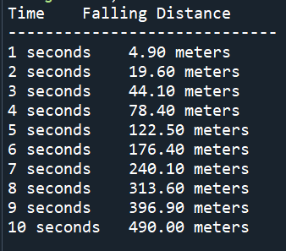
Problem2: Prime numbers
Write a function named is_prime which takes an integer as an argument and prints if it is prime or composite. Prime numbers are those which are divisible by 1 and the number itself. Write a main function that call the is_prime function in a loop and passes numbers 2 to 10 as arguments.
Expected Output:
